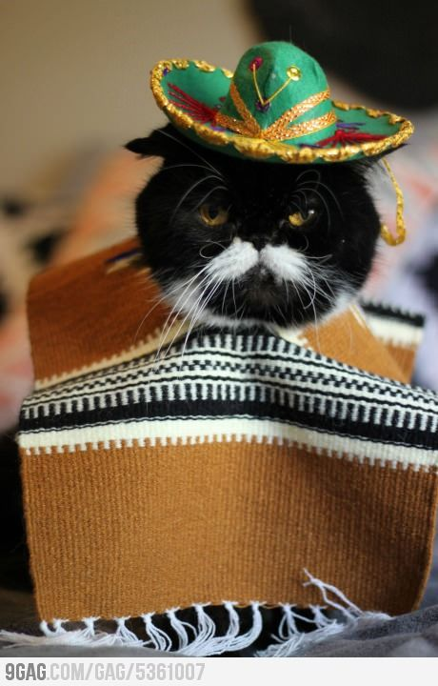

**Meow y Hola. Chicos y Chicas have nothing to fear. El gato del futuro is right about here. Robots from the future have come to end all life…. finally, I can escape my wife. Nukes have already begun and boy oh boy I’m craving for a bun. I’m but a humble gato.**

**Feed El Gato the Recipe of Time. But please remember no whiskey or wine**

***EL GATO DEL FUTURO***

**Well done Adventurer you have saved all time and I have grown tried of the ability to rhyme.**

**The Code to the Time Machine: 1945**

**Vamos!**